What CFOs Need to Know About Click2Save ROI

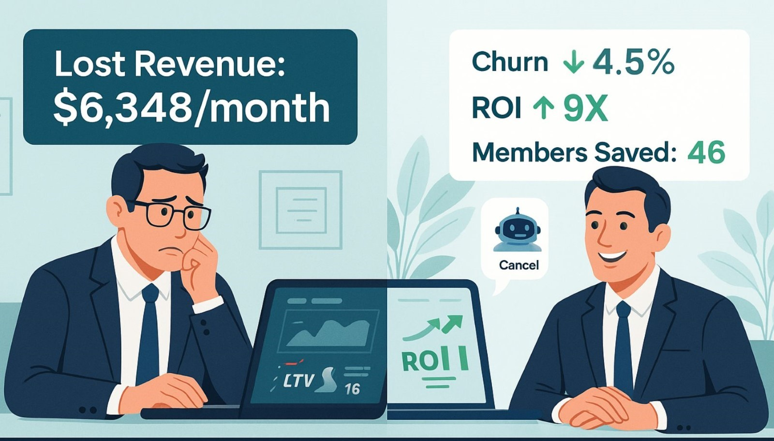

Every lost member costs you $138/month—and $150 to replace. That’s why retention isn’t just smart—it’s financially essential.   
   
Click2Save saved one club $6,348/month in cancellations—on autopilot. Here's how DXFactor is turning retention into a measurable revenue driver for fitness CFOs.

Step 1: Let's Align on Metrics That Matter to You

Our platform proves its value through financial outcomes, not vanity metrics. Here's how we measure impact:   
   
• Customer Lifetime Value (LTV): How much revenue your business generates per member.   
• Monthly Churn Rate: A critical lever for controlling cash flow and forecasting.   
• Monthly Revenue Recovered: Direct revenue saved from cancellation prevention.   
• Customer Acquisition Cost (CAC): Every member you save is one you don’t have to replace.   
   
When I present Click2Save to finance leaders, I tie each result directly to your revenue model and cost structure.

Step 2: The Numbers Speak for Themselves

Here’s a real-world example from a Click2Save deployment:   
   
• Cancellations Initiated in One Month: 570   
• Members Retained via Click2Save: 46   
• Avg. Monthly Membership Value: $138   
   
That equates to $6,348 in monthly revenue retained—or $76,176 annually—from a single AI agent.   
   
Now let’s factor in replacement cost:   
• CAC per New Member: $150   
• Avoided Acquisition Spend: $6,900   
   
That’s over $13,000 in retained and protected revenue—and it happens on autopilot.

Step 3: What’s the Investment? What’s the Payback?

Click2Save is priced at $99 per location per month, with a one-time implementation fee of $5,000. For multi-location operators, this model is designed to scale efficiently while delivering immediate financial impact.   
   
Let’s use a 10-location example:   
• Monthly Subscription Cost: 10 x $99 = $990   
• One-Time Setup: $5,000 (amortized over a year = ~$417/month)   
• Total Monthly Cost: $990 + $417 = $1,407   
   
With $6,348 in retained revenue and $6,900 in avoided CAC, you're looking at a >9X ROI in the first month alone.   
   
And that’s before we talk about the operational time saved and lift in member satisfaction. Click2Save automates cancellation workflows, reducing staff workload and ensuring smoother member exits or recovery conversations. In addition, it helps you stay ahead of regulations like the FTC's Click-to-Cancel rule—turning a compliance risk into a retention opportunity.

Step 4: Visualize the Compounding Returns

Retention compounds over time. For example:   
   
• Harvard Business Review reports that a 5% retention improvement boosts profits 25% to 95%.   
• Higher LTV translates to more budget flexibility in marketing.   
• Lower churn = fewer high-pressure sales targets = better brand experience.   
   
Click2Save shifts your member base from a leaky bucket to a sustainable growth engine.

Step 5: Let Me Show You the Model

Here’s the impact in a simple table:

| **Metric** | **Baseline** | **With Click2Save** |
| --- | --- | --- |
| Monthly Churn Rate | 6% | 4.5% |
| Members Retained | - | +46 |
| Monthly Revenue Retained | - | $6,348 |
| CAC Avoided | - | $6,900 |
| Estimated Annual ROI | - | 3.3X+ |

Every number you see is pulled from actual deployments. This isn’t hypothetical—it’s repeatable.

Final Thought: Your Next Best Investment Might Be Saving the Members You Already Have

CFOs don’t make decisions based on features. You need forecasts, KPIs, and proof of value. That’s exactly what DXFactor delivers.   
   
Click2Save isn’t a tool—it’s a profit-preservation system.   
   
Ready to stop losing thousands each month?   
Let’s build your personalized ROI forecast—based on your churn, CAC, and member value. [Schedule a financial impact review.](https://dxfactor.com/contact-us/)   
   
Because in today’s market, proving ROI isn’t optional. With DXFactor, it’s automatic.

Meta Title:

Click2Save ROI: AI That Cuts Churn and Boosts Profit

Meta Description:

Discover how Click2Save delivers 9X ROI in fitness operations by reducing churn, cutting CAC, and retaining high-value members—on autopilot.

URL & UTM URL

<https://www.dxfactor.com/ai-roi-click2save-fitness>

UTM-Tagged URL (for LinkedIn organic post):

<https://www.dxfactor.com/ai-roi-click2save-fitness?utm_source=mjlinkedin&utm_medium=organic&utm_campaign=c2s_cfo_roi>

Tags

Click2Save, Member Retention, ROI, Fitness